* **[32933 Research Project - Spring 2022](https://canvas.uts.edu.au/courses/24142)**

**Research Proposal**

**Group Member:**

Xin Song 13379235

Hanlin Shi 13411350

Ruic Chen 13841604

**Project Type:** Type I – Prototype-based project

**1. Research Title:**

A Web Development of Rate and Review Professors Based on HTML5, CSS3 and PHP

**2. Abstract**

To track the teaching quality of the university and let students have more reference materials when choosing courses, we are going to develop a professor teaching evaluation system. The functions provided by the system are as follows:

a) Students who have chosen a course taught by a professor can view the professor's profile, mainly to understand his/her academic direction and research results and the relevance to the current course

b) After the course of each semester, students can rate the overall teaching situation of the professor, and the rating is calculated by weighted average to get the final result, which will be published on the website.

c)At the beginning of the new semester, professors will publish the courses they teach on this website for students to choose, so that it is easier to choose courses suitable for their own development and a matching professor

With the rapid development of web technology, the development of management information systems has become more and more popular. In order to achieve a good user experience, this system uses PHP dynamic web page technology combining HTML5 and CSS3 to build a beautiful user interface, the user data is saved in the MySQL database.

**3. Introduction**

Today, there are various websites on the Internet, they have different functions and responsibilities. However, we have noticed that among the various websites in Australia, there is no website dedicated to grading teachers, and our team hopes to fill this vacancy. It is very important for students to choose their favorite professors, and a planned study plan can help them complete their studies more smoothly. On our website, users will inquire about the relevant resumes of professors in various disciplines, including but not limited to teaching experience, subjects, student evaluations, teaching scores, etc. After students log on to the site, they can create a document for their professor, and then fill in the relevant information to help future freshmen. This is a comprehensive and systematic project, and the evaluation of teachers' teaching quality is undoubtedly an extremely important aspect and an important means to improve teaching quality. The evaluation of teachers' teaching quality is an important means of teachers' self-development. Through the evaluation of teachers' teaching quality, on the one hand, teachers can clarify the direction and goals of their efforts; on the other hand, teachers can find and eliminate problems existing in teaching.

**3. Research Questions**

This research will build a website for users to rate and review professors in Australia. The aim of this research is to answer the following questions:

* What sources of information do Australian university students use when they decide which classes to take?
* What is the commercial and technological viability of the Rate and Review Professors/Lectures website in Australia?
* Does the Rate and Review professor website really reflect the true and objective professors’ situation correctly?

**4. Objectives**

The objectives of this research are the following:

* Design the Website pages using HTML5, CSS3 and JS
* Use PHP language for creating dynamic Web pages
* Use PHP & MySQL for reading, writing and verifying data
* Create an online rate and review website using a combination of scripting languages, descriptive languages, development tools and back-end databases.
* Build a grading-score algorithm and mechanism to ensure the fairness of the scoring system.
* Use AWS Elastic Beanstalk for website deployment

**5. Timeline and tasks**

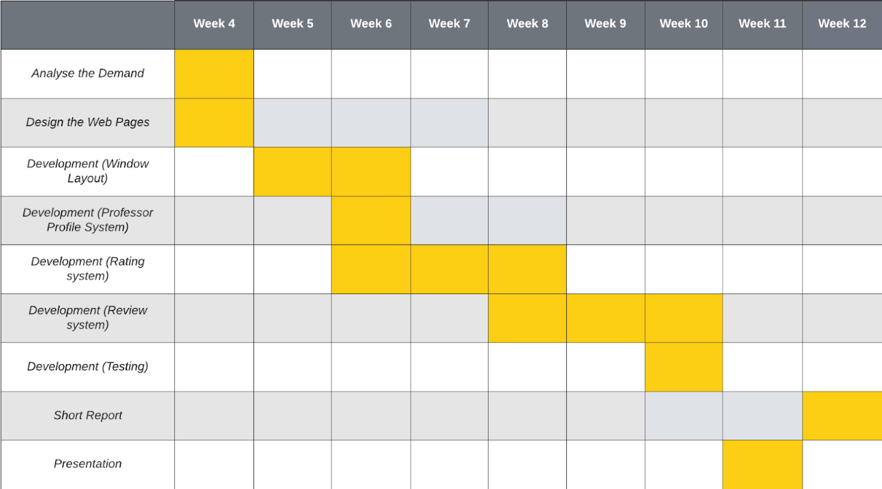

**6. Purpose**

The ultimate aim of this research is to provide an online platform for all university students to rate and review professors or teachers and help peers make correct choices before they select courses.